Water Quality in the River Clyde

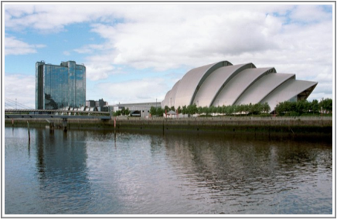
A report on an HEA sponsored project

Adrian Bowman
The University of Glasgow
June 21st 2012

Background
This project addresses the need for teaching materials in the mathematical sciences which relate to the sustainability theme promoted by the HEA. The origin of the material is a collaborative study undertaken by the Department of Statistics in conjunction with the Scottish Environment Protection Agency some years ago, involving the analysis of data on water quality in the River Clyde. This study was subsequently used in talks given to schools and other organisations, to provide an example of how statistical methods are used to solve real problems and so to indicate the role of statistics in the world at large.
Around six years ago, a separate project in the University of Glasgow, also partly HEA sponsored, developed a package for the widely used statistical computing system R, which gave easy access to tools for the creation of graphical user interface controls, such as buttons, sliders etc. This package is called rpanel. Although its facilities have quite general applications, there are particular applications in teaching, in the use of animated graphics to communicate statistical concepts and methods in an attractive, intuitive and interactive manner.
An opportunity then arose two combine these two developments by making the water quality data and its analysis available in the rpanel environment. This report describes the resulting material and how it may be used in teaching.

Developed material
There are three principal components, as described below.
- A text file called clyde.r containing R code to run the software. In order to run this, the R system needs to be available with the rpanel package installed. These are both easily available from www.r-project.org.
- A document containing Notes for Teachers. This describes how the software may be used in a teaching context.
- A document containing Notes for Students. This can be used as handout for students.



A screenshot of the application, with an illustration of fitting a harmonic regression model to the water quality data from a single sampling station.

Evaluation
The case study has been used in lecture form in a variety of settings over the years, so the material has had the benefit of refinement through practice and informal feedback. More particularly, the software was recently illustrated and discussed at a weekend residential conference in Cambridge organised by the Prince's Teaching Trust. The conference participants were practicing teachers so this provided an excellent opportunity for feedback.

Availability
The current drafts of the software, the data and the associated documents are currently available at
www.stats.gla.ac.uk/~adrian/clyde.r
www.stats.gla.ac.uk/~adrian/clyde.dat
www.stats.gla.ac.uk/~adrian/clyde-teacher.pdf
www.stats.gla.ac.uk/~adrian/clyde-student.pdf
During the summer months of 2012 a new version of rpanel should be released. It is planned to incorporate the Clyde case study into the package directly, to make the material as easily accessible as possible. It will then be available directly, through an item in the rp.cartoons menu. As part of this release, some further refinements of the software and the presentation of the case study will also be undertaken.

